Columbia College Chicago

Canvas Pilot Group
Resource Guide

Table of Contents
Introduction 2
Training and Help Resources 5
Canvas Global Navigation 7
Canvas Courses 8
Moodle to Canvas Migration Checklist 11
Pilot Group Feedback Notes 15
Colors and Branding Options 17

Introduction

Why Canvas?
Canvas is a modern, cloud based learning management system (LMS) and educational platform that supports a deep focus on teaching and learning. The robust features of Canvas enhance teaching and learning beyond the physical classroom, and include a superior suite of tools, advanced easy-to-use interface, improved collaboration and the ability to easily integrate with many external tools for future enhancements. Implementing Canvas at Columbia College Chicago lays the foundation for instructors to be truly aspirational with:
Boosting student engagement:

Canvas features an easy-to-use, learner-centered, content-focused design with:
- A consistent interface for students across courses
- A single, connected, multi-course calendar
- Sophisticated rich content editor for embedding video content, math formulas, and other rich media
- Dynamic syllabus which includes assignments by due date
- Mobile apps that provide content for people on-the-go
Canvas encourages students to learn from each other through:
- Intuitive assignment and grading options
- Group collaboration workspaces including built-in conferencing tool
- Easy peer review functionality
- Office 365 integration for collaborative projects
Providing for better feedback:
Canvas makes it easy to provide effective feedback to enhance student learning by offering:
- The ability to map student participation to grading feedback
- Simple grading with timely feedback options (SpeedGrader)
- Rich, multimedia feedback options (including text, audio and video commenting in messages, assignments, course discussions, graded work and grade submissions) — without downloading and re-uploading files

Preparing for the future:
Canvas has so many advanced features that they all can’t be listed in this resource guide. Rest assured that these advanced features (such as learning outcomes, mastery paths, and course analytics) will be rolled out in the next phase of the Canvas implementation.
Additionally, as technology changes at a rapid pace, Canvas is setup to easily integrate third-party learning technologies with just a few clicks. This provides Columbia College Chicago the opportunity to stay on the cutting edge with new educational offerings.

How This Resource Guide Works?
This resource guide is designed to guide instructors during the pilot stage of the Canvas implementation. Training and helpful resource options are provided, including video and web-based guides covering the basic features of Canvas.
Content migration from Moodle to Canvas did not always translate and some cleanup was required. This resource guide includes an important migration checklist to double check content transferred properly. We encourage the pilot group to complete this handy checklist for each of their courses.
While instructors are testing out the features of Canvas, this resource guide provides for a feedback section to easily capture notes and thoughts on-the-spot. A short, online survey will be given to pilot group participants after the semester starts. However, jotting down what was tested may help when completing this survey.
Lastly, the branding of Canvas can be customizable. We’ve provided a few examples of colors approved by the marketing department at Columbia College Chicago. We would love the pilot group to provide feedback on the branding and colors, so the last section of this resource guide provides screen shots of the various branding options.

Now it’s time to get started testing out Canvas!!

- Login to Canvas: canvas.colum.edu
- Username and Password: Oasis ID (same as email, etc).

Training and Help Resources
There are five resources available for instructors who may need help in their transition from Moodle to Canvas.
Resource | Where to Find?
Academic Technology Team | - Jamie Ackley & Evan West
Canvas Guides | - Instructor Guides, Student Guides
Canvas Training Events | - Live Canvas Events – Note - must create a Canvas training portal login – different than Columbia account. After account creation, sign on to Canvas Training Portal  - Videos of Canvas Events  - Canvas YouTube Videos  - Canvas Internal Videos
Lynda.com | - Access to Lynda.com is free to faculty. Just login to OASIS, click on the training tab and follow the lynda.com link, then search "Canvas 2016” to get started.
Canvas 24/7 Help and Chat | - Login to Canvas: https://canvas.colum.edu - select Help under the Global navigation menu.

Below please find helpful information if instructors choose to use the Canvas mobile app.

Canvas Mobile App
Where to Go? | 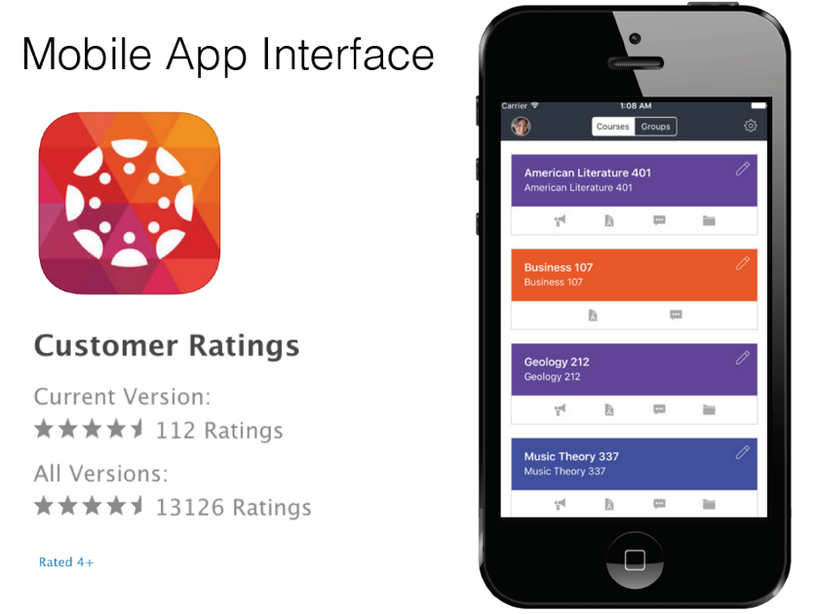  Guides, Video Android, Video iOS, SpeedGrader App
- Go to App Store
- Search Canvas by Instructure

- Enter Columbia College Chicago to search for school

- Select Columbia College Chicago
Do not select Columbia College Chicago Online (as that is the Digital Learning version of Canvas).

Canvas Global Navigation

Global Navigation within Canvas includes the left hand side menu that instructors and students see “before” they enter an actual course. Below are guides and short video clips on how to use the Canvas Global Navigation.

Canvas Global Features | Help Resources
Account | - Guides, Video
Account Notifications | - PDF
Dashboard | - Guide 1, Guide 2
Customizing Course List | - Guides
Calendar | - Guides, Video
Inbox (Conversations) | - Guides
Commons | - Guides

Canvas Courses

Instructors will spend the majority of their time in a Canvas course creating and designing workflow of course content. Below are guides and short video clips on how to use the Canvas course features.

Canvas Course Features | Help Resources
Course Settings: Course Details | - Guides
Course Settings: Navigation | - Guides
Course Settings: Student View | - Guides
Course Settings: General | - Video – Part 1, Video – Part 2
Home | - Guides, Video (coming soon)
Announcements | - Guides, Video
Syllabus | - Guides, Video
Rich Content Editor | - Guides, Video
Modules | - Guides, Video
Assignments: Creating | - Guides, Video
Assignments: Assignment Groups (Weighting) | - Guides, Video
Attendance | - Guides, Video: (note – this is a video created by another school, as Canvas did not have a video available yet for this new feature)
Discussions | - Guides, Video
Other Communication features | - Video
Grades | - Guides, Video
SpeedGrader | - Guides, Video, SpeedGrader App Video
Interactive Rubrics | - Guides, Video
Conferences (BigBlue Button) | - Guides, Video
Collaboration (Google Docs or Office 365) | - Guides, Video
Quizzes: Create a Quiz | - Guides, Video
Quizzes: Create Questions | - Guides, Videos
Chat | - Guides, Video
Files | - Guides, Video
Pages | - Guides, Video
People | - Guides, Video: (coming soon)
People: Groups | - Guides, Video
Office 365 | - Guides: (coming soon), Video: (note – this is a video created by another school, as Canvas did not have a video available yet for this new feature)
Course Analytics – note: Course Analytics will not appear in a course until there are active students participating. | - Guides, Video (coming soon)

Complete List of Instructor Guides
Complete List of Videos

Moodle to Canvas Migration Checklist

Content migration from Moodle to Canvas does not always translate and some cleanup will be required. Below includes a migration checklist to ensure content transferred properly, along with some basic cleanup suggestions. We encourage the pilot group participants to complete this handy checklist for each of their courses.

Moodle to Canvas Migration Checklist |  |  | Help Resources
 | Announcement | Suggestion – place an announcement in your Moodle course that you will be using Canvas this term. Direct students to Canvas URL: canvas.colum.edu and the student guides. | Student Guides
 | Course Navigation | Review the course menu in your Canvas course. Decide if some menu items should be hidden from students (instructors can always see menu items anytime). | Guides
 | Course Image | Upload a course image that appears on course card. If you don’t have one handy, there is a built-in option to search flicker creative commons.
 | Syllabus | Update syllabus by either copying and pasting in the rich text editor of the syllabus area, or uploading a Word or PDF file. | Guides, Video
 | Front Page (home) | Decide what students will see when they first enter your course. Options include welcome page, syllabus or modules (modules are the default). | Guides
 | Modules: Title Names | Based on how content was set up in Moodle, super long names may appear in titles in Canvas. These can be confusing for students. Edit module names, such as Week 1, Week 2, Week 3, etc. | Guides, Video
 | Modules: Page names | Based how content was set up in Moodle, super long names may also appear in the page titles. Edit and rename page names, such as Week 1: Overview. | Guides, Video
 | Module: Reorder Content | Content within modules are delivered to students in a logical format, such as what to be completed first, second, third, etc. This is different than how Moodle handles content. Using the easy drop and drag feature, reordered content based on this criterion. For example, first content item within a module may be a weekly overview, followed by a reading, video, discussion board, then quiz and assignment coming last. | Guides, Video
 | Module: Headers | Text sometimes migrated to canvas as a content heading. Remove or update these headings within each module. | Guides, Video
 | Moodle Blocks | Moodle blocks do not migrate. If you’ve created a block in Moodle that holds content, you will have to manually copy and paste into a new Canvas page, then place with the module in the desired order.
 | Pages: Images | Sometimes images embedded into a page didn’t always migrate. Manually re-load image to the files sections in the Canvas course and place them in the desired page. | Guides, Video
 | Pages: No content | Sometimes a page migrated from Moodle just with an image and no content. This may be a great opportunity to place a quick overview of what will be covered during the week on this page. | Guides, Video
 | Pages: Check Links | Sometimes links (especially those as pdf’s), will link back to Moodle content. Just relink them to the pdf in Canvas files within a course. | Guides, Video
 | Pages: Book | There is not a book feature in Canvas. If content from Moodle was created using the Book feature, the content did migrate. You’ll find it in the page’s area. However, it will have to manually placed into the desired module and in the logical order. | Guides, Video
 | Assignments | Assignments did migrate very cleanly. However, instructors need to confirm score and change due dates. These are important, as they due dates appear in many different areas in Canvas (calendar, syllabus, to-do list). | Guides, Video
 | Assignments Groups | All assignments from Moodle appear in the Imported Assignment Group. Students will see this name and it may be confusing. Simply renaming this assignment group is the easiest fix.  If weighting grades, create additional assignment groups. Then simply drop and drag assignments into that group. Students will see how grades are weighted within the syllabus area.
 | Discussion Board | Change the names of forums to match those of modules. For example, Week 1 Discussion forum. This makes it easier for students and instructors in the grade book. | Guides, Video
 | Grades | There is not any gradebook set up in Canvas. All set ups are done in the Assignment area. However, this is a good time just to double check the Grade Book is accurate from what was shown in the Moodle course.
 | Quizzes | Quizzes appear to migrate from Moodle to Canvas as practice quizzes. Practice quizzes do not calculate in the total column. Check each quiz and change to “graded quiz”. | Guides, Video
 | Published | Course are automatically in an unpublished state, meaning students can’t see the course until instructors are ready with their course content. When your course design is complete, publish the course.  Even if a course is published, individual items that were migrated can be hidden from students. Check each individual content area and check that it has a bright green cloud next to it. | Guides
 | Student View | Instructors can see everything in Canvas, but there may be items hidden from students. To double check that students are seeing what you desire, enter the course as a student. Under settings, select Student View. Take quizzes, submit assignments and look at content flow. When finished, the test student will appear in your course for the rest of the term. | Guides

Pilot Group Feedback Notes

Although, there will be an short online survey provided to the pilot group participants in the upcoming months, below is an area for pilot group participants to write notes as you use the features of Canvas.
Training and Help Resources
 | What did you review? | Your feedback:
1
2
3
4
5

Global Navigation
 | What did you review? | Your feedback:
1
2
3
4
5

Canvas Courses
 | What did you review? | Your feedback:
1
2
3
4
5

Migration of Content from Moodle
 | What did you review? | Your feedback:
1
2
3
4
5

Canvas App
 | What did you review? | Your feedback:
1
2
3
4
5

Colors and Branding Options
Below are three branding options approved by the marketing department of Columbia College Chicago.
Option 1: Black – Bubble Gum
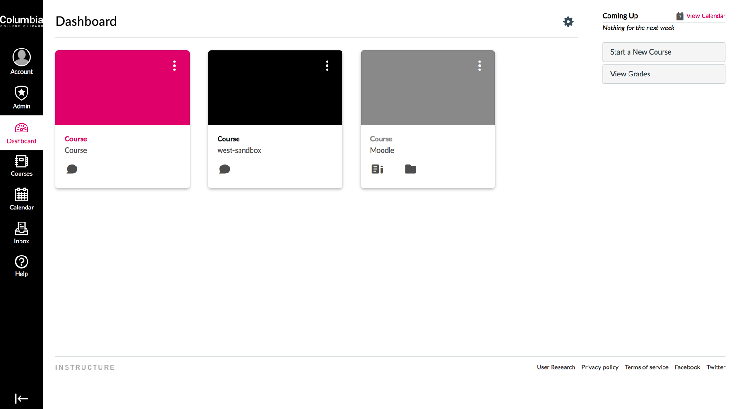

Option 2: Burnham Blue
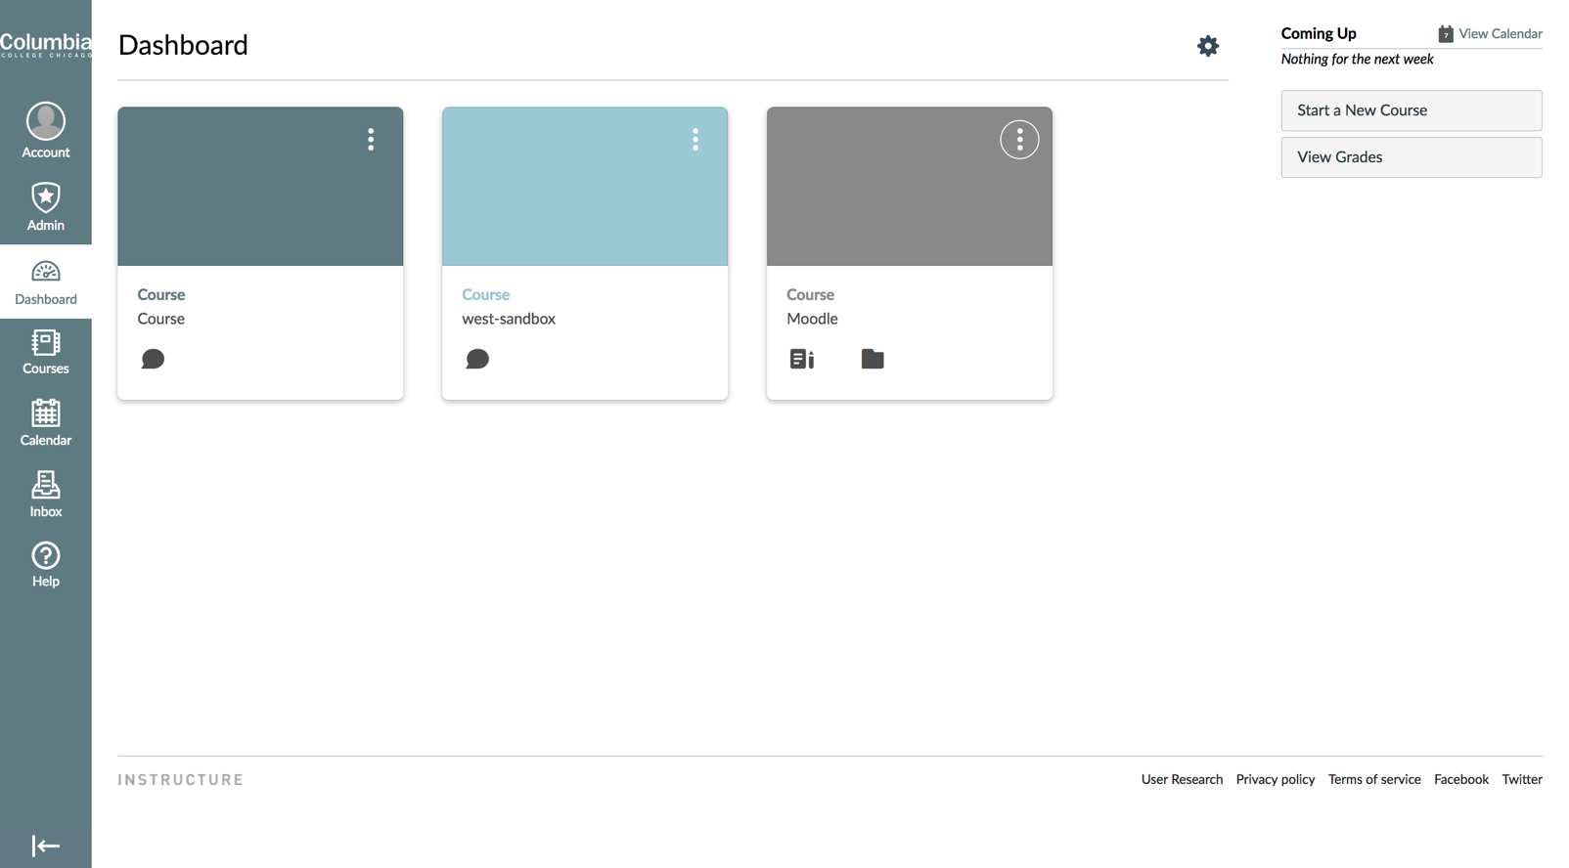

Option 3: Production Purple
